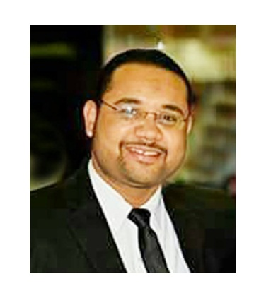
CURRICULUM VITAE
Mohammed Hamada Takrouney (M. Sc.)
Full Name  Sex  Date of birth  Nationality  Marital status  Current affiliations | Mohammed Hamada Takrouney Mohammed Ahmed  Male  1st January 1988  Egyptian  Married and has children  Department of General surgery ,Pediatric Surgery Unit, Assiut University Hospital, Assiut, Egypt.  Post-code: 71111, EGYPT.  Phone: Work: +2-088-2414564.  Fax: +2-088-2343308  E-mail: m.takrouney1988@aun.edu.eg  m.takrouney1988@gmail.com
Speciality  Subspeciality  Advanced Skills | General Surgery.  Pediatric surgery  Neonatal surgery  Laparocopic surgical interventions  Upper and lower GIT Endoscopy.

Post Held
From / To | Affiliation | Posts
March 2012 / Feb. 2013 | Assiut University Hospital | General House Officer (Intern.)
March 2013 / Sept. 2015 | Assiut University Hospital  General surgery Department | Resident doctor (SHO equivalent)
Sept. 2015 / July 2016 | Assiut University Hospital of Pediatrics  Pediatric Surgery Unit . | Academic Demonstrator in Pediatric Surgery Unit .
August 2015 / Now | Assiut University Hospital of Pediatrics  Pediatric Surgery Unit | Assistant lecturer
Clinical Experience
Assiut, Egypt (2012-2015):
Assiut University Hospital (AUH), Department of General surgery Department ,140 bed for adult patients for different general surgery disease, Assiut University Emergency Unit for Surgical emergency
Pediatric Unit of Surgery , Assiut University Hospital Of Pediatrics (2015-till now):
It is the first specialized center in Pediatric Surgery in Upper Egypt and now is already in work.

Teaching & Academic Experience
Teaching sessions:
- Teaching Pediatric Surgery (Lectures and Clinical Rounds).
Writing & Editing:
- Patient sheet and data base
- Postgraduate logbook and course specifications

Courses and Conference attendance
TRAINING COURSES (As a trainee):
- ICDL
- FLDP courses to Improvement of skills
- SPSS course
- Advances in Anorectal Malformation and Hirschsprung disease (December 2017,Cairo ,Eygpt By Prof.Alberto Pena and Dr. Andrea Bischoff.
- 2nd Advanced Pediatric Laparoscopy Workshop (pediatric surgery unit ,Minia University, Eygpt)
- Hands on Workshop of Oncoplastic Breast Surgery (General Surgery department ,Assiut University in collaboration with Mansoura Oncology Association .
- Workshop in Evidence Based Medicine in Assiut University .
- Workshop in Infection Control in Assiut University .
- Hands on Hypospadias Workshop (Prof. Anne Francoise from Belgium , Prof. Alexander Springer From Austria And Prof. Ibrahim Ulman from Turkey in Ain Sham Specialised Hospital).
- Upper and Lower diagnostic GIT Endoscopy (7 days Hand on).
CONFERNCE ATTENDANCE
- The 31st Congress of the Egyptian Paediatric Surgical Association (EPSA)
- The 32nd Congress of the Egyptian Paediatric Surgical Association (EPSA)
- The Scientific Conference of Paediatric Unit Of Sohag University in Collaboration with Egyptian Paediatric Surgery Association .
- The Scientific Conference of Paediatric Unit Of Minia University in Collaboration with Egyptian Paediatric Surgery Association .
- Sohag 2nd Annual International Conference of Surgery , Laparo-endoscopy and Oncology.
- Assiut General Surgery Department Annual Conference and Workshop .

- The 30 Annual Scientific Conference of Faculty of Medicine , Assiut University

- The 31st Annual Scientific Conference of Faculty of Medicine , Assiut University

Publications:
1-Torsion of Enlarged Wandering Spleen in Child with Gaucher's Disease .
2- Laparoscopic cholecystectomy for symptomatic multiseptate gallbladder.
3- Unique Anomalies of Vas Deferens; A Case Series from Upper Egypt.
4-Primary acquired Gastric Outlet Obstruction in Pediatrics (Jodhpur Disease) , How to Manage?, A report of Two Cases.
5-Traumatic Spinal Hernia in A child , A novel Variant of traumatic Hernia .(Poster in Annual conference of faculty of medicine).
6-An unusal Case of Crossed Testicular Ectopia.(Poster in Annual conference of faculty of medicine)
7-Inguinal Herniotomy in Baby with Epidermolysis Bullosa , How to manage ? (Poster in Annual conference of EPSA)

